# **Introduction.**

## **Purpose.**

The purpose of this document is to design a specification for a I.O.T Project, for a final year student studying Computer Science.

The whole initial idea was an I.O.T garden, where measurements like oxygen, carbon dioxide, soil moisture, sunlight and many more quantities can be stored in some type of database and then displayed to the user, I will hopefully also allow a user implement some type of watering / plant feeding timetable where the plants are fed at a certain time of day, or even allow the user a way of pressing a button to feed them.

I got the initial idea as my family sponsor cups in the Keep Kilkenny Beautiful gardening competition, but I have never won, I thought even starting a robotic garden would be an innovation.

Currently right now the project would not be outdoors, it would be all indoors but I could mimic the conditions.

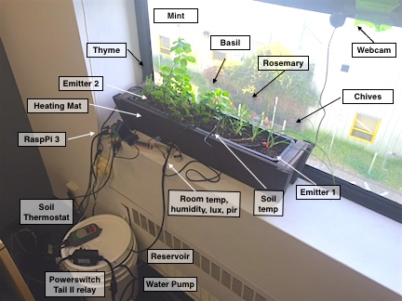

## **Project Goals.**

The goal of this project is to have an automated garden where I can maintain the well being of a garden using the power of the internet of things and measure things like oxygen, carbon dioxide, and water plants using an android application.

The idea would be to interface the sensors to a raspberry pi, print them to a database (firebase) and then display the results in an app.

For example if I wasn’t happy with the level of moisture in the soil, I could press a button, the water pump would turn on and the flowers would get sprinkled with water.

I would also like a report where I could see the soil moisture, over a period of time, or even the oxygen and carbon dioxide produced in the area.

|  |  |
| --- | --- |
| Cyberbank + Firebase | Technisys Digital Banking Platform | |
| Raspberry Pi 3 Icons PNG - Free PNG and Icons Downloads | Phone Icon Android #60455 - Free Icons Library |

# **Research.**

## **Connections to Other Projects or Assignments.**

There are many other projects available online, but a many of them a lot more advanced, the following image is where the user of the application can control the plants light source, my own project wont be that advanced although it should be able to measure and display moisture, oxygen, carbon dioxide, PH level, and have some type of water metering.

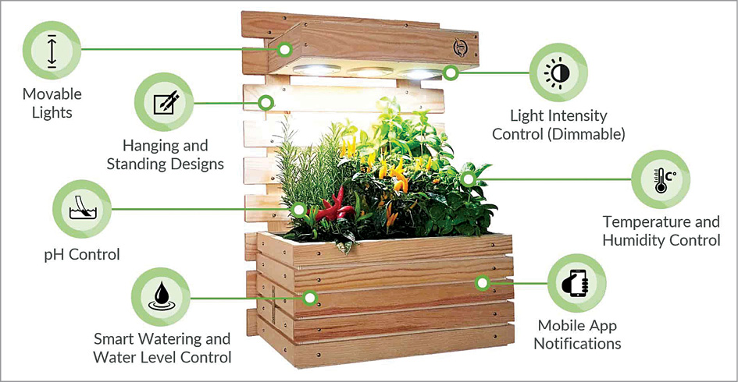

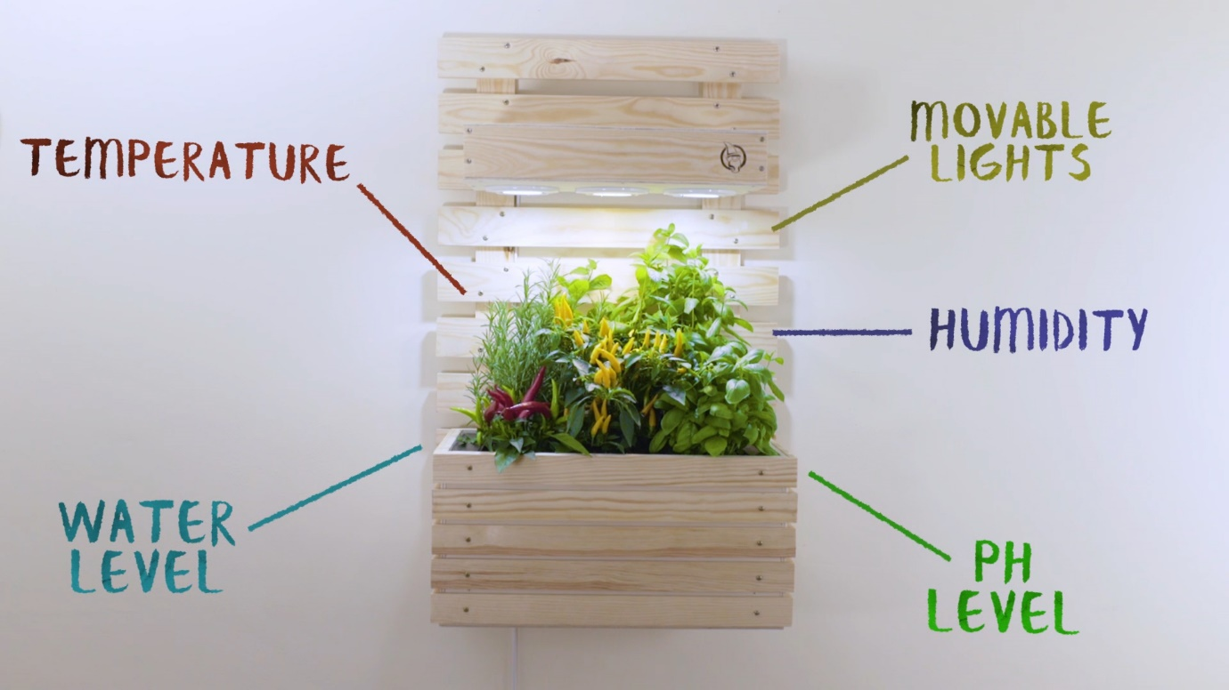

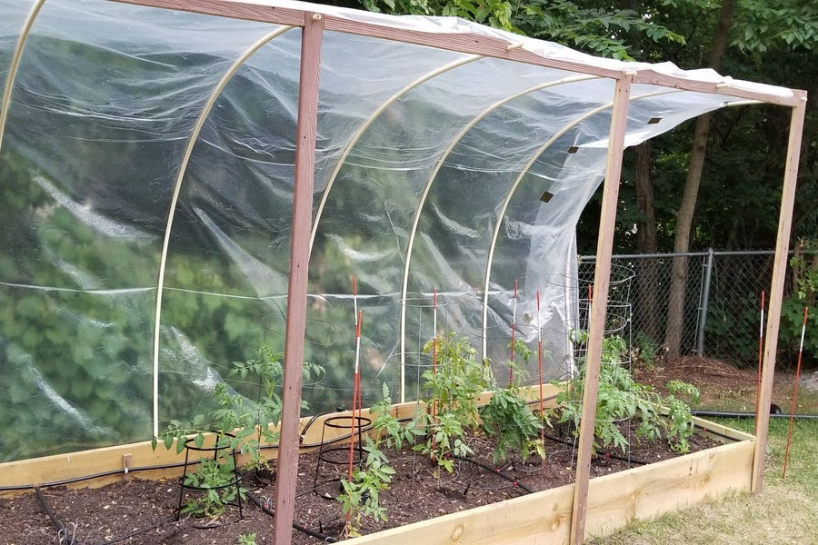

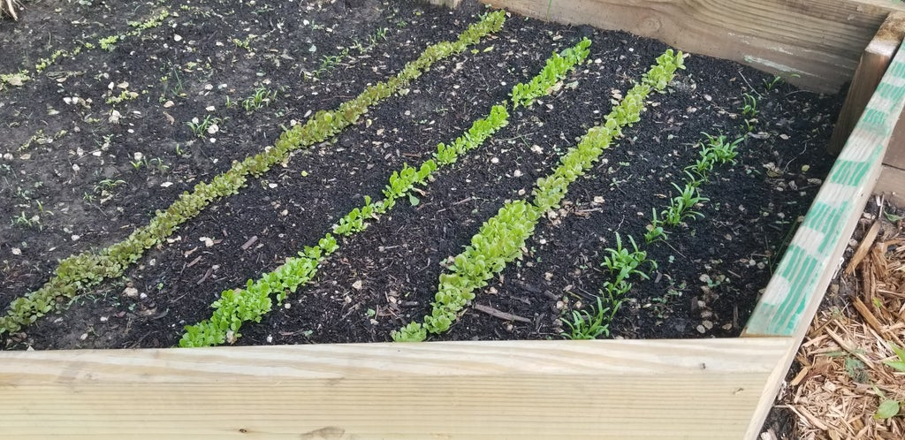

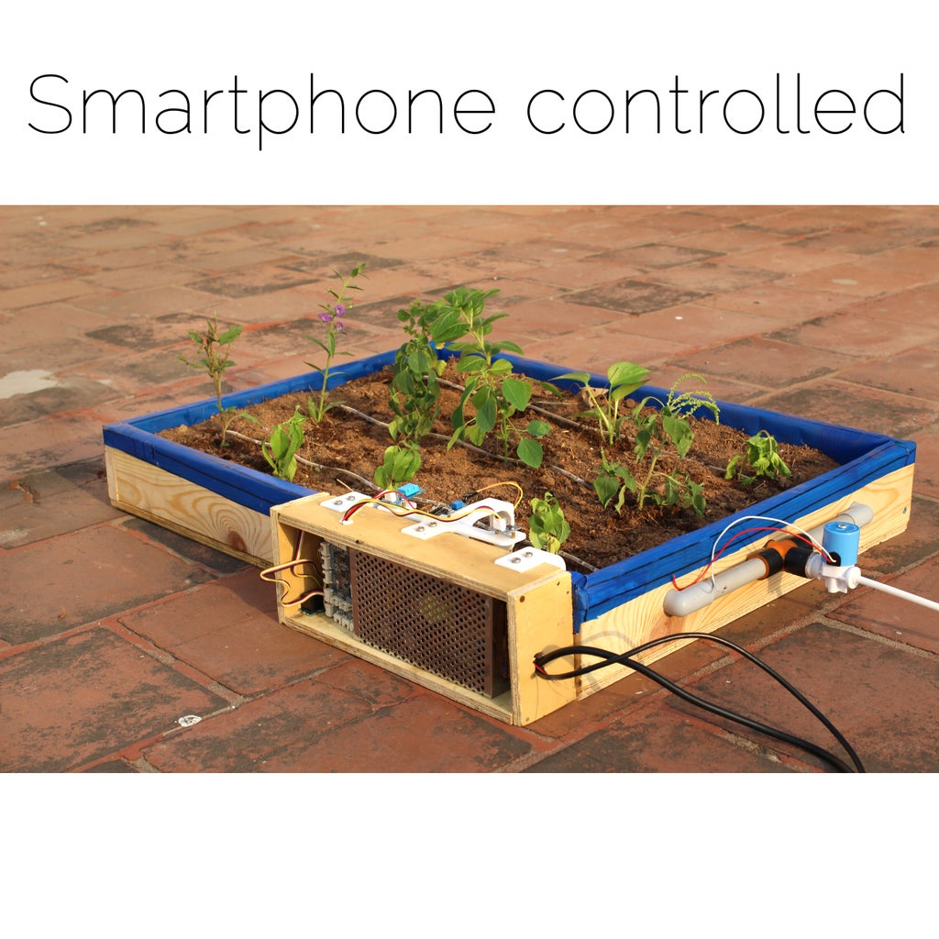.

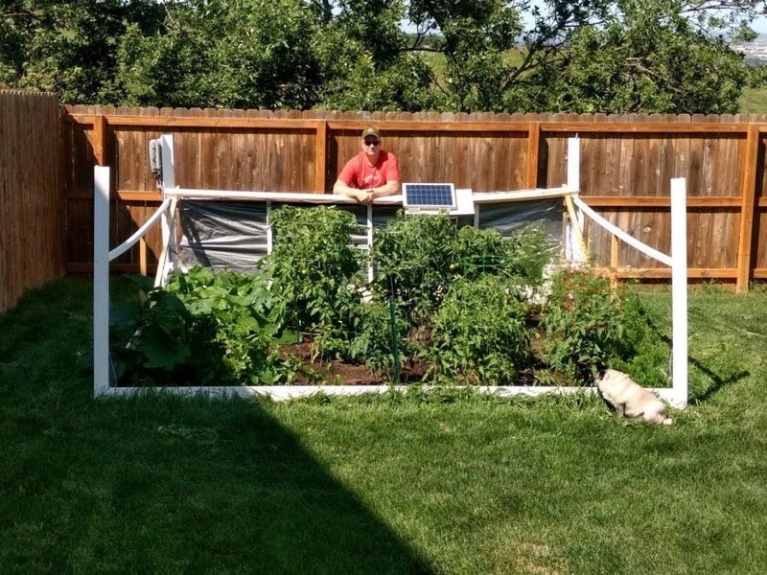

## **Planned Materials and Sensors.**

### **Raspberry Pi.**

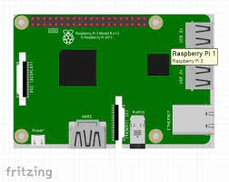

### **DHT22 Temperature / Humidity Sensor.**

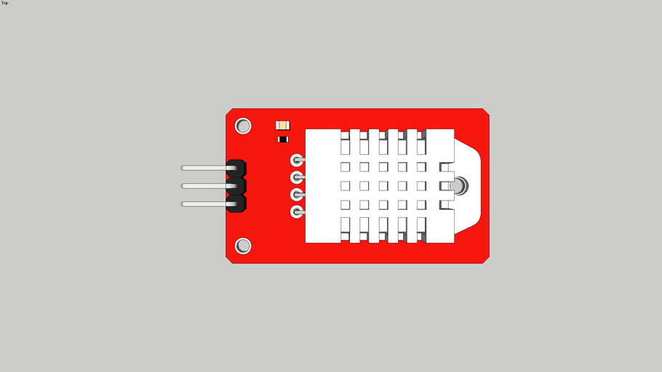

### **Water Pump.**

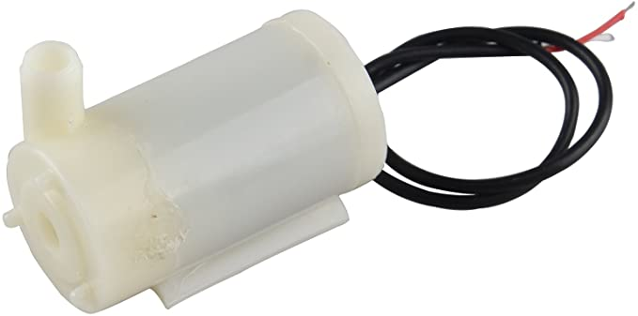

### **Luminosity Sensor.**

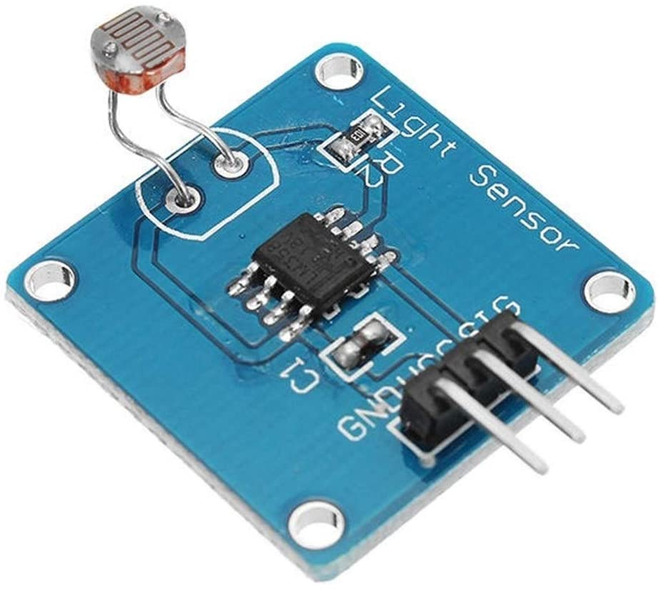

### **Soil Moisture Sensor.**

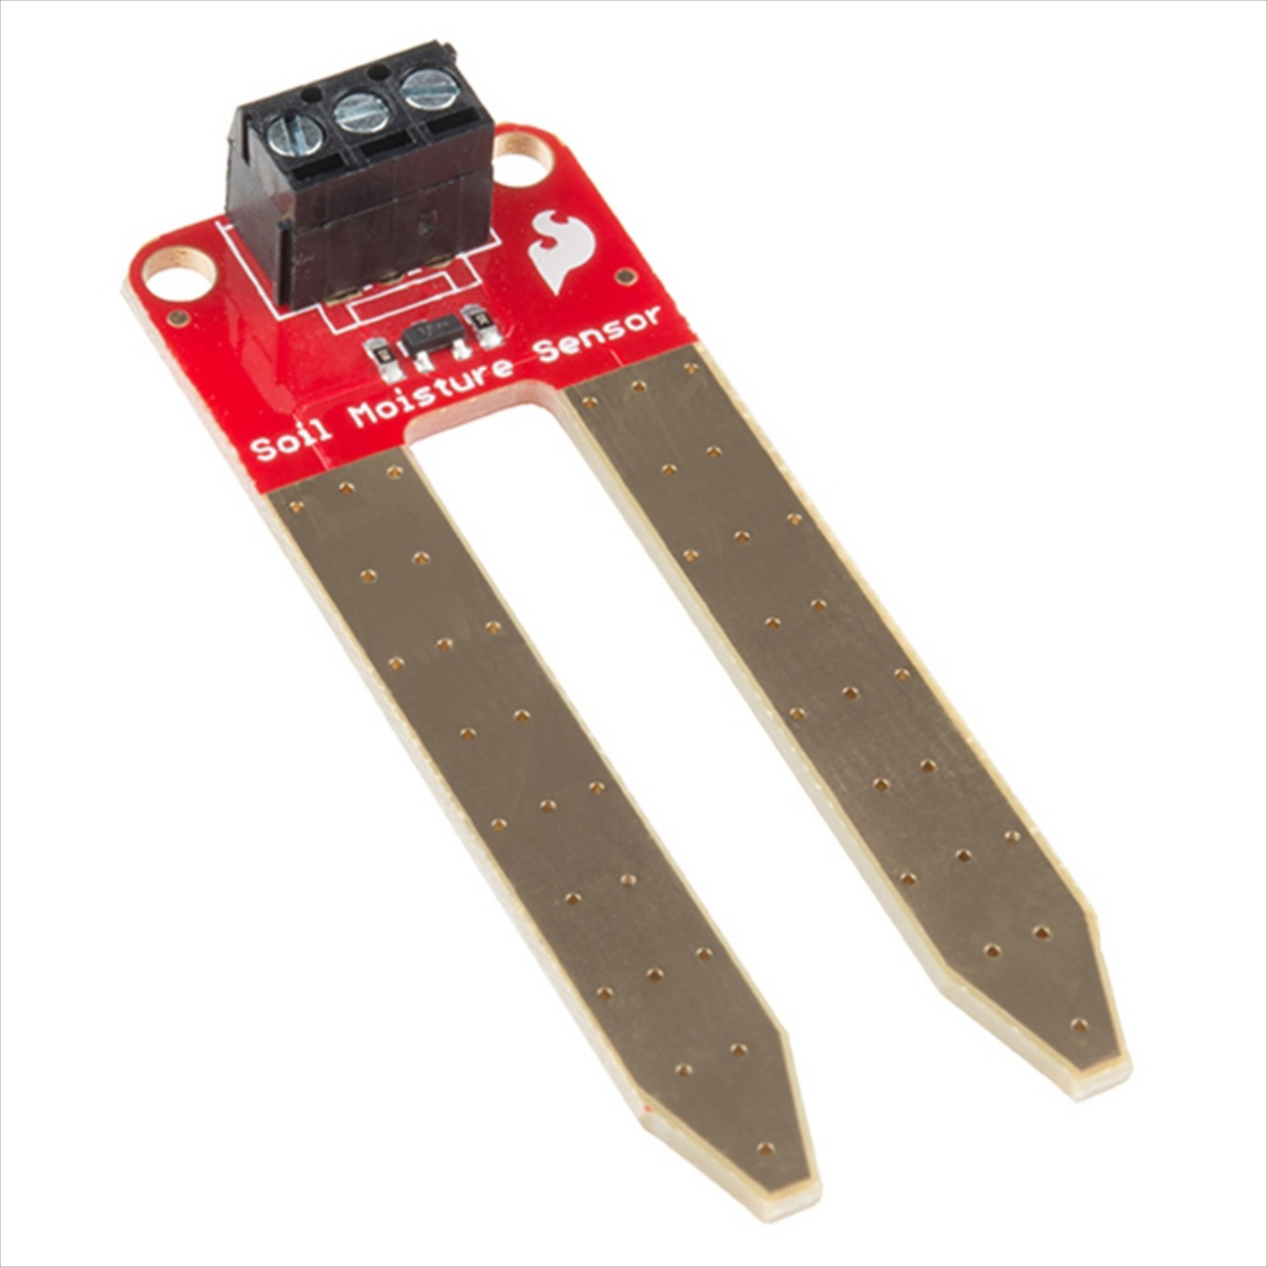

### 

### **Android Phone.**



1. Timeline.
   1. Time schedule.
   2. Project Milestones.
   3. Delivery Plans.
2. Project Hand Over.
3. Project Final Specification.
4. Discussion.